FRTB Standardised Approach
Securitisation Sensitivity Methodology
CSR Sec Non-CTP (MAR21.20) · GIRR Delta (MAR21.19)

1. Executive Summary
This document sets out the end-to-end methodology for computing FRTB Standardised Approach market risk sensitivities for securitisation positions classified as CSR Sec Non-CTP under MAR22. Two risk measures are produced for each tranche: Credit Spread Risk (CSR) delta — the CS01 at five prescribed tenors — and General Interest Rate Risk (GIRR) delta — the PV01 at up to ten FRTB GIRR tenors. Together these sensitivities feed directly into the FRTB SA capital calculation (Sensitivity-Based Method, MAR21) as inputs to bucket-level aggregation, inter-bucket correlation, and finally the overall capital requirement under the low / medium / high correlation scenarios.
The calculation engine is implemented in Python, using QuantLib for full cashflow discounting, and covers fifteen tranche positions across six structured finance asset classes: RMBS, CMBS, CLO, ABCP, ABS-Auto, and ABS-CreditCard.

2. Applicable Instruments
The securitisation methodology applies to all positions where the FRTB Risk Class field contains "CSR_SEC_NONCTP" in the portfolio file (Combined Holdings sheet). The current portfolio contains 15 such positions across six structured-finance asset classes, including two short positions (negative notional) representing hedges or short-selling of mezzanine tranches.
ID | Security | Asset Class | Tranche | Rating | Notional | L/S | Bucket | Attach–Detach
37 | RMBS-2023-1-A (Senior) | RMBS | Senior | AAA | $50M | Long | 1 | 15% – 100%
38 | RMBS-2023-1-M (Mezz) | RMBS | Mezzanine | BBB | $15M | Long | 9 | 5% – 15%
39 | RMBS-2023-1-B (Short Mezz) | RMBS | Mezzanine | BBB | $5M | Short | 9 | 5% – 15%
40 | CMBS-2024-RE1-A1 (Senior) | CMBS | Senior | AA | $100M | Long | 4 | 25% – 100%
41 | CMBS-2024-RE1-A2 | CMBS | Senior | A | $8M | Long | 4 | 20% – 25%
42 | CMBS-2024-RE1-B (Mezz) | CMBS | Mezzanine | BBB | $15M | Long | 12 | 10% – 20%
43 | CLO-2019-LVG-A (Senior) | CLO | Senior | AAA | $200M | Long | 8 | 30% – 100%
44 | CLO-2023-LVG-B (Mezz) | CLO | Mezzanine | AA | $45M | Long | 16 | 15% – 30%
45 | CLO-2023-LVG-C (Mezz) | CLO | Mezzanine | AA | $20M | Long | 16 | 15% – 30%
46 | ABCP MultiSeller 2025 | ABCP | Senior | A-1 | $300M | Long | 6 | 0% – 100%
47 | CC-ABS-2024-A (Senior) | ABS-CreditCard | Senior | AAA | $150M | Long | 6 | 12% – 100%
48 | CC-ABS-2024-B (Mezz) | ABS-CreditCard | Mezzanine | AA | $20M | Long | 14 | 6% – 12%
49 | CC-ABS-2024-C (Junior) | ABS-CreditCard | Junior | BBB | $11M | Long | 14 | 0% – 6%
50 | AUTO-2024-1-A (Senior) | ABS-Auto | Senior | AAA | $80M | Long | 7 | 15% – 100%
51 | AUTO-2024-1-B (Short Mezz) | ABS-Auto | Mezzanine | A | $12M | Short | 15 | 5% – 15%
Table 1: Portfolio of securitisation tranches. Short positions (RMBS-B and AUTO-B) carry negative notional; their sensitivities are positive (opposite sign to long positions), reflecting an obligation to deliver the tranche on a short sale.

3. Data Sourcing

3.1 Notionals and Static Data
All static attributes — notional, issue date, maturity, coupon, attachment/detachment points, pool type, and Long/Short flag — are sourced from the portfolio file (FRTB_Combined_Portfolio_v4.xlsx, "Combined Holdings" sheet). Notionals are face-value origination amounts and are not adjusted for market price. A negative notional denotes a short position and propagates through to a negative-notional QuantLib bond object, so that NPV and hence all sensitivities carry the correct sign without any manual sign flip.

3.2 Risk-Free Base Curve — USD SOFR
The USD risk-free discounting curve follows MAR21.39: the overnight-indexed swap (OIS) rate based on the Secured Overnight Financing Rate (SOFR) is used as the risk-free benchmark. Rates are sourced from the market data snapshot (market_data_snapshot_5Feb2026.xlsx) as of 5 February 2026:
Tenor | SOFR OIS Rate
6M | 4.05%
1Y | 3.99%
2Y | 3.50%
3Y | 3.42%
5Y | 3.36%
7Y | 3.50%
10Y | 3.65%
20Y | 3.85%
30Y | 3.95%
Table 2: USD SOFR curve snapshot, 5 February 2026.
The raw SOFR rates are linearly interpolated onto the ten FRTB GIRR prescribed tenors {0.25, 0.5, 1, 2, 3, 5, 10, 15, 20, 30} years via _snap_to_frtb_tenors() in data_loader.py, and a QuantLib ZeroCurve object is constructed with Actual/365 Fixed day-count and extrapolation enabled. This snapped curve is the base handle used in all subsequent discounting and bump-and-reprice operations.

3.3 Tranche Spread Curves (Level 3 Construction)
Securitisation tranche spread curves are not directly observable in the market for most positions. A "Level 3" manufactured spread curve is constructed per tranche using the following three inputs:
- Base spread anchor: the 5-year base spread in basis points, calibrated from rating-matched indices (e.g., AAA RMBS 5y ≈ 75 bps) and adjusted for the tranche's specific attachment/detachment profile.
- Thinness premium: an additional spread loading to compensate for reduced secondary market liquidity at the specific attachment/detachment window. Thinner tranches (smaller notional windows) receive a higher premium.
- Term shape: the spread term structure is constructed from the anchor at 5 years using a market-implied shape factor. Short tenors are typically tighter than long tenors for investment-grade tranches (upward-sloping spread curve).
The five pillar spreads are stored per instrument ID in the "Sec_Tranche_Curves" sheet of the market data workbook and loaded by _load_tranche_curves() (data_loader.py). Spreads are stored in basis points and converted to decimal (÷ 10,000) on load.
ID | Security | Pool | Rtg | Base 5y  (bps) | Thin.  (bps) | sp_0.5Y | sp_1Y | sp_3Y | sp_5Y | sp_10Y
37 | RMBS-2023-1-A (Senior) | RMBS | AAA | 75 | 26.1 | 85.9 | 93.0 | 101.1 | 109.2 | 119.3
38 | RMBS-2023-1-M (Mezz) | RMBS | BBB | 280 | 33.5 | 266.5 | 288.4 | 313.5 | 338.6 | 369.9
39 | RMBS-2023-1-B (Short Mezz) | RMBS | BBB | 280 | 33.5 | 266.5 | 288.4 | 313.5 | 338.6 | 369.9
40 | CMBS-2024-RE1-A1 (Senior) | CMBS | AA | 145 | 23.2 | 142.9 | 154.7 | 168.2 | 181.6 | 198.4
41 | CMBS-2024-RE1-A2 | CMBS | A | 215 | 34.0 | 211.7 | 229.1 | 249.0 | 268.9 | 293.8
42 | CMBS-2024-RE1-B (Mezz) | CMBS | BBB | 360 | 32.0 | 333.2 | 360.6 | 392.0 | 423.4 | 462.6
43 | CLO-2019-LVG-A (Senior) | CLO | AAA | 145 | 21.7 | 141.7 | 153.4 | 166.7 | 180.1 | 196.7
44 | CLO-2023-LVG-B (Mezz) | CLO | AA | 200 | 28.8 | 194.5 | 210.5 | 228.8 | 247.1 | 270.0
45 | CLO-2023-LVG-C (Mezz) | CLO | AA | 200 | 28.8 | 194.5 | 210.5 | 228.8 | 247.1 | 270.0
46 | ABCP MultiSeller 2025 | ABCP | A-1 | 45 | 30.5 | 64.2 | 69.5 | 75.5 | 81.5 | 89.1
47 | CC-ABS-2024-A (Senior) | ABS-CreditCard | AAA | 55 | 27.0 | 69.7 | 75.4 | 82.0 | 88.5 | 96.7
48 | CC-ABS-2024-B (Mezz) | ABS-CreditCard | AA | 85 | 36.5 | 103.3 | 111.8 | 121.5 | 131.3 | 143.4
49 | CC-ABS-2024-C (Junior) | ABS-CreditCard | BBB | 230 | 38.3 | 228.1 | 246.9 | 268.3 | 289.8 | 316.6
50 | AUTO-2024-1-A (Senior) | ABS-Auto | AAA | 60 | 26.1 | 73.2 | 79.2 | 86.1 | 93.0 | 101.6
51 | AUTO-2024-1-B (Short Mezz) | ABS-Auto | A | 145 | 33.5 | 151.7 | 164.2 | 178.5 | 192.8 | 210.6
Table 3: Manufactured tranche spread curves (all values in basis points).

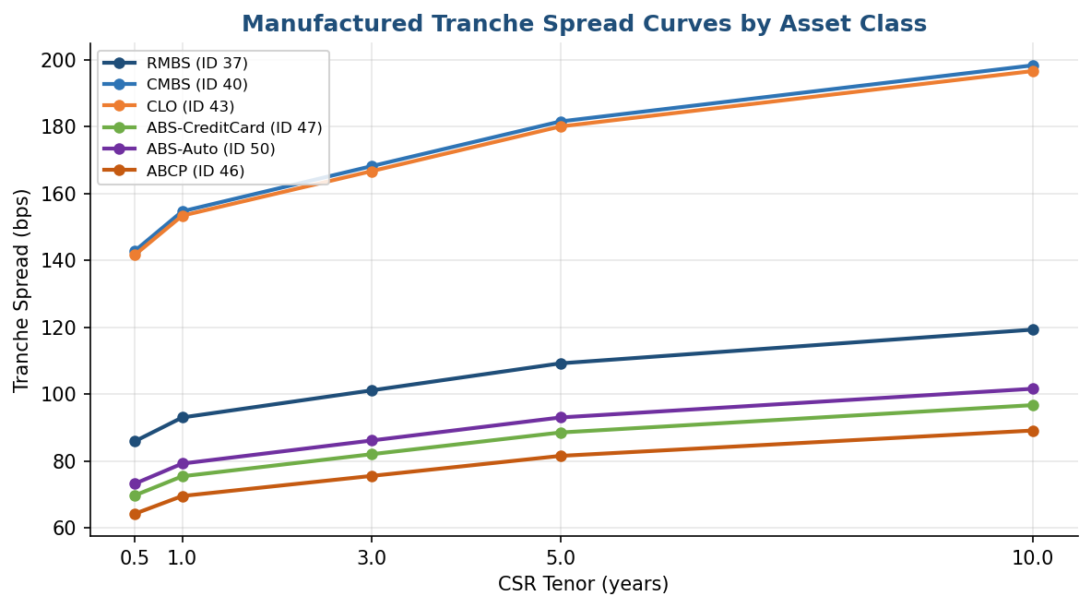
Figure 1: Tranche spread term structures by asset class (representative positions). ABCP sits lowest (≈45–90 bps) due to its short maturity and senior ranking. CLO-B mezzanine is widest at longer tenors, reflecting leveraged-loan collateral risk.

4. Asset-Class Amortisation Profiles
The cashflow schedule of each tranche is constructed by sec_cashflows.project_tranche_bond() using an asset-class-specific principal amortisation profile. The profile determines the outstanding-notional vector passed to QuantLib's AmortizingFixedRateBond (or FixedRateBond for bullet structures). Correct cashflow timing is essential because it determines both coupon income and principal returns, which in turn drive the sensitivity of the bond PV to spread and rate movements.
Asset Class | Profile | Rationale | Key Assumption
CMBS | Bullet | Full notional outstanding until legal final maturity; 100% balloon at maturity. Mirrors commercial mortgage structures where individual loans carry balloon maturities aligned to the deal's legal final. | n/a
ABCP | Bullet | Short-dated (typically ≤1 year); full face redeemed at maturity. Asset-backed commercial paper is rolled continuously in the market. | n/a
ABS-Auto | Linear | Equal principal slice repaid each period over the full life. Consumer auto loan portfolios exhibit close-to-linear amortisation given regular monthly repayments from borrowers over a fixed term. | n/a
CLO | Reinvest → Sequential | No paydown during the reinvestment period (manager redeploys principal proceeds into new loans). Sequential linear amortisation from end-of-reinvestment to maturity. | 5-year reinvestment period (Western Asset/Citi 2021; Invesco 2024)
ABS-CreditCard | Revolving → Controlled | Revolving (coupon-only) on full notional until the controlled amortisation period, then linear paydown. Credit card pools top up through new purchases during the revolving phase. | 1-year controlled amortisation period
RMBS | CPR Declining Balance | Outstanding notional decays at a constant Conditional Prepayment Rate applied each period to the remaining balance. The CPR embeds voluntary prepayment and reflects the prevailing mortgage rate environment. | 8% annual CPR (long-run prime US RMBS proxy)
Table 4: Amortisation profile by asset class with rationale and key assumptions.

CMBS / ABCP — Bullet (flat at 100%) No principal returned until maturity. The entire notional is outstanding for the full term, producing the highest duration among all asset classes. A 1bp rate move affects the full discounted value of the principal, so GIRR and CSR sensitivities are proportional to the remaining maturity — the most interest-rate-sensitive profile in the portfolio.

CLO — Reinvest → Sequential (flat then ramp down) The flat segment (years 0–5) is the reinvestment period: principal receipts from underlying loans are recycled into new assets, keeping the tranche notional constant. At year 5 the manager loses reinvestment discretion and sequential paydown begins — notional falls rapidly. The kink at year 5 is a contractual cliff, not a market effect; it makes CLO duration sensitive to whether the deal is inside or outside its reinvestment window.

ABS-Auto — Linear (straight diagonal) Reflects the monthly instalment structure of auto loans: equal principal repayments each period. Duration declines uniformly and predictably. Low convexity — the sensitivity profile is nearly symmetric around the mid-life point. The most analytically straightforward profile for FRTB bucketing.

ABS-CC — Revolving → Controlled (late cliff) Credit card receivables continuously repay and are replaced by new spend, so the notional stays flat for approximately 9 years (revolving). A short 1-year controlled amortisation window then returns all principal. The effect is close to a bullet but with a compressed paydown — duration is high throughout the revolving period, then collapses sharply.

RMBS — CPR bands (3%, 8%, 20%) — convex decay Unlike all other profiles, RMBS amortisation is not contractually scheduled — it is driven by borrower prepayments. The Conditional Prepayment Rate (CPR) applies to the current outstanding balance each period, not the original notional. This produces geometric (exponential) decay rather than linear: the curve bows above a straight line between its start and end points, which is the defining visual signature. Three consequences matter for FRTB:
- Higher CPR → shorter WAL → sensitivity concentrates at shorter GIRR and CSR tenors
- CPR uncertainty is a model assumption risk: the 3%–20% band shown here represents the range from a stress refinancing environment to an accelerated paydown scenario; CS01 can vary by a factor of ~2× across this range
- Convexity means duration is not constant: as rates fall, prepayments accelerate, shortening duration exactly when you'd want it to be long — negative convexity embedded in the mortgage pool passes through to the tranche

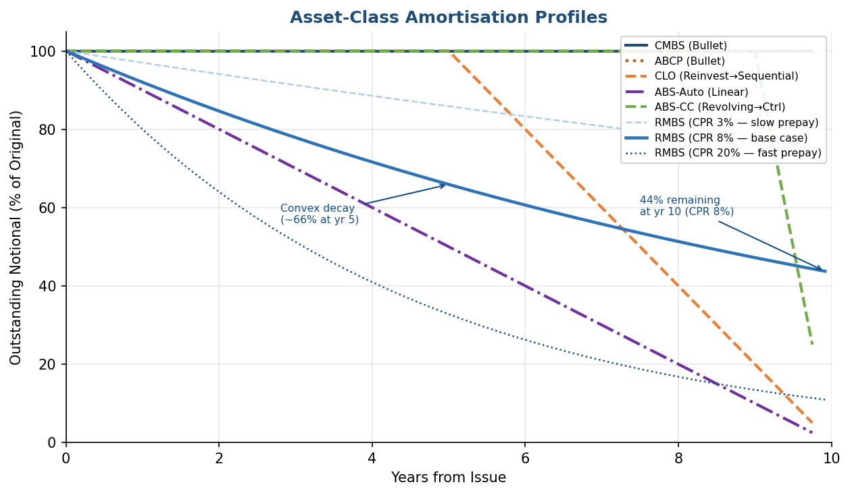

5. Technical Methodology
The calculation follows a strict separation of concerns across four modules, each with a well-defined input/output contract:
- data_loader.py — loads portfolio, market data, and tranche curves; builds QuantLib curve handles.
- sec_cashflows.py — constructs the QuantLib bond object (cashflow schedule + amortisation).
- sensitivity_calc.py — runs the bump-and-reprice loops for CSR and GIRR.
- orchestrator.py — routes each instrument and assembles the output DataFrame.

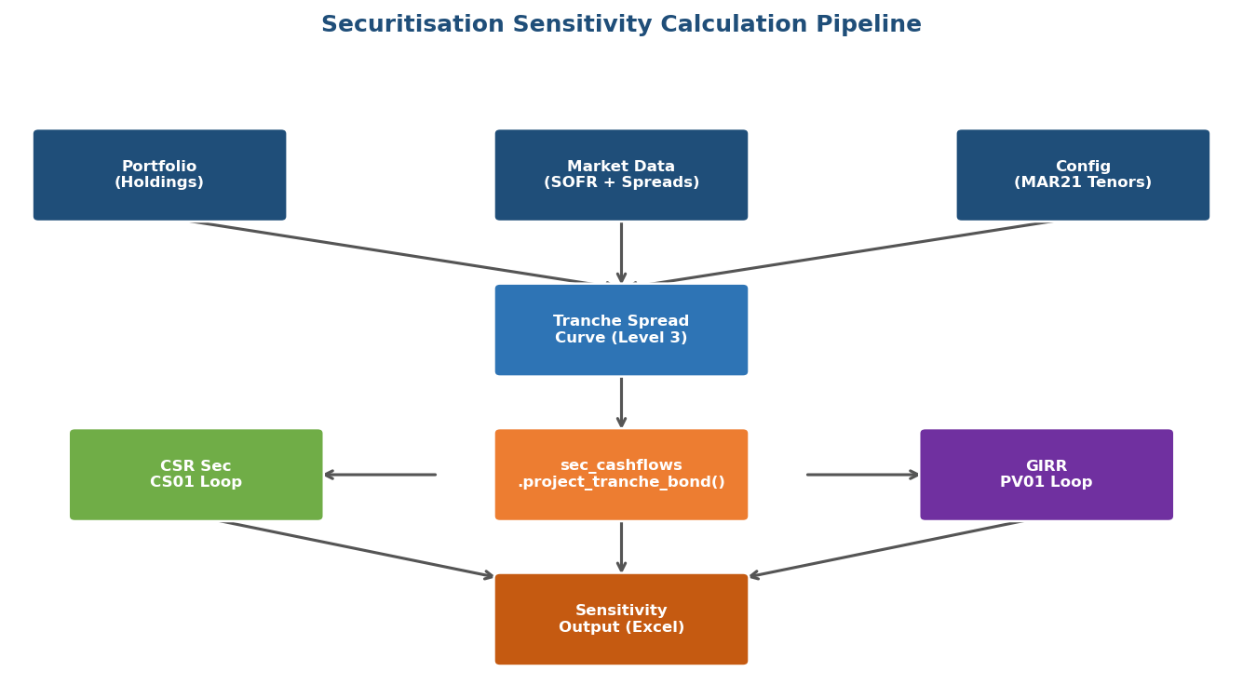
Figure 3: End-to-end calculation pipeline. Blue boxes are data inputs; the orange box is cashflow construction; green/purple boxes are the two independent bump-and-reprice loops; brown box is the output writer.

5.1 Bond Construction — sec_cashflows.project_tranche_bond()
This function is the single entry point for all securitisation cashflow work. It dispatches on pool_type to one of six private notional-vector builders (see Section 4), constructs a QuantLib payment schedule from issue to maturity using Actual/365 Fixed day-count and US Government Bond calendar with Modified Following business day convention, then builds either:
- ql.AmortizingFixedRateBond — for RMBS, CLO, ABS-Auto, ABS-CreditCard (varying outstanding notional per period).
- ql.FixedRateBond — for CMBS and ABCP (constant notional, simpler structure).
Short positions are handled by negating the notional vector before passing it to AmortizingFixedRateBond, or by attaching a frtb_sign = -1.0 attribute to a FixedRateBond (which cannot accept a negative face value). The calling function multiplies NPV by frtb_sign, so sensitivity signs flow through naturally.

5.2 Combined Discount Curve
The tranche is discounted on a combined curve:
Discount Rate(t) = SOFR(t) + TranchSpread(t)
This is implemented via ql.SpreadedLinearZeroInterpolatedTermStructure, which takes the USD SOFR handle and a list of (date, spread) pillar pairs and produces a composite zero curve with linear interpolation in zero-rate space. An anchor pillar at the valuation date is added equal to the shortest tenor spread, ensuring short-dated cashflows are correctly discounted. extrapolation is enabled on the combined curve.
This design makes a critical distinction between the two sensitivities: CSR bumps the spread pillar while holding SOFR fixed; GIRR bumps the SOFR pillar while holding tranche spreads fixed. The combined curve structure enforces this separation cleanly.

5.3 CSR Delta — CS01 Calculation (MAR21.20, MAR22.60)
For each of the five prescribed CSR tenors τ ∈ {0.5, 1, 3, 5, 10} years:
- All five tranche spread pillars are instantiated as ql.SimpleQuote objects.
- The base PV is computed: PV₀ = NPV(SOFR + base_spreads) × sign.
- For the target tenor τ, setValue(s_τ + 0.0001) is called — a +1 bp bump.
- Repricing is automatic via QuantLib's observer pattern: the combined curve propagates the changed quote to the pricing engine without curve rebuild.
- CS01(τ) = (PV_bumped − PV₀) / 0.0001
- The spread quote is restored via setValue(s_τ) before the next tenor loop.
Bumping a single pillar by +1 bp while adjacent pillars remain unchanged produces a triangular kernel that peaks at tenor τ and decays linearly to zero at the adjacent FRTB tenors — the Ho (1992) / Reitano (1992) triangular perturbation, which is consistent with the MAR21.8 footnote 3 treatment of inter-tenor interpolation. Sensitivities are reported as CSR_SEC_NONCTP_{bucket}_{τ}Y and are denominated in USD per basis point (positive = loss when spread widens).

5.4 GIRR Delta — PV01 Calculation (MAR21.19)
For each FRTB GIRR tenor β ∈ {0.25, 0.5, 1, 2, 3, 5, 10, 15, 20, 30} years (subject to a maturity cut-off of mat + 5 years):
- The tranche spread quotes are set to their base values and frozen as plain floats — no observer bump is needed.
- _build_bumped_curve() rebuilds the USD SOFR ZeroCurve with a +1 bp perturbation at tenor β only, leaving all other pillars unchanged.
- A new combined handle is constructed (SpreadedLinearZeroInterpolatedTermStructure on the bumped SOFR base + fixed spreads) and attached to the pricing engine.
- PV01(β) = (NPV_bumped × sign − PV₀) / 0.0001
Because the full SOFR ZeroCurve must be rebuilt for each tenor bump (unlike the CSR case where observer updates suffice), the GIRR loop rebuilds the discount handle at each tenor. The tranche spread structure is re-attached to each new SOFR base, so the "spread fixed, rate bumped" orthogonality is maintained exactly. Sensitivities are reported as GIRR_USD_{β}Y.

5.5 Key Rates and Functions Called
Function / Class | Purpose
data_loader._snap_to_frtb_tenors() | Interpolate raw SOFR rates to FRTB tenor grid
data_loader._build_ql_curve() | Build QuantLib ZeroCurve from {tenor: rate} dict
data_loader._load_tranche_curves() | Read Sec_Tranche_Curves sheet; convert bps → decimal
sec_cashflows.project_tranche_bond() | Build amortising/bullet QuantLib bond per pool type
sensitivity_calc._build_bumped_curve() | Rebuild SOFR ZeroCurve with +1bp at one tenor
sensitivity_calc.calc_securitisation_csr_delta() | CSR CS01 loop (5 tenors, SimpleQuote bumps)
sensitivity_calc.calc_securitisation_girr_delta() | GIRR PV01 loop (up to 10 tenors, curve rebuild)
ql.SpreadedLinearZeroInterpolatedTermStructure | Composite SOFR + spread curve with linear zero interpolation
ql.AmortizingFixedRateBond / ql.FixedRateBond | Cashflow schedule and NPV engine
ql.DiscountingBondEngine | Attaches yield curve to bond for NPV computation
Table 5: Key functions and QuantLib classes used in the securitisation sensitivity engine.

6. Computed Sensitivities
All figures are computed as of 5 February 2026 and are denominated in USD per basis point of spread or rate movement (+1 bp). Negative values indicate that the position loses value when the relevant rate or spread increases by 1 bp (typical for a long bond); positive values indicate a short position or that the instrument benefits from a widening.

6.1 CSR Sec Non-CTP Sensitivities
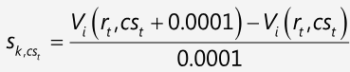
ID | Security | Pool | L/S | Bucket | Total CSR | Dom. Tenor | Dom. CS01
37 | RMBS-2023-1-A (Senior) | RMBS | Long | 1 | $-94.1M | 3.0Y | $-81.8M
38 | RMBS-2023-1-M (Mezz) | RMBS | Long | 9 | $-26.7M | 3.0Y | $-23.1M
39 | RMBS-2023-1-B (Short Mezz) | RMBS | Short | 9 | $8.9M | 3.0Y | $7.7M
40 | CMBS-2024-RE1-A1 (Senior) | CMBS | Long | 4 | $-636.4M | 10.0Y | $-384.1M
41 | CMBS-2024-RE1-A2 | CMBS | Long | 4 | $-47.3M | 10.0Y | $-28.4M
42 | CMBS-2024-RE1-B (Mezz) | CMBS | Long | 12 | $-78.0M | 10.0Y | $-46.5M
43 | CLO-2019-LVG-A (Senior) | CLO | Long | 8 | $-336.3M | 3.0Y | $-173.7M
44 | CLO-2023-LVG-B (Mezz) | CLO | Long | 16 | $-144.9M | 3.0Y | $-83.7M
45 | CLO-2023-LVG-C (Mezz) | CLO | Long | 16 | $-64.4M | 3.0Y | $-37.2M
46 | ABCP MultiSeller 2025 | ABCP | Long | 6 | $-191.9M | 0.5Y | $-134.5M
47 | CC-ABS-2024-A (Senior) | ABS-CreditCard | Long | 6 | $-386.9M | 3.0Y | $-320.6M
48 | CC-ABS-2024-B (Mezz) | ABS-CreditCard | Long | 14 | $-51.0M | 3.0Y | $-42.3M
49 | CC-ABS-2024-C (Junior) | ABS-CreditCard | Long | 14 | $-27.0M | 3.0Y | $-22.3M
50 | AUTO-2024-1-A (Senior) | ABS-Auto | Long | 7 | $-89.2M | 3.0Y | $-53.5M
51 | AUTO-2024-1-B (Short Mezz) | ABS-Auto | Short | 15 | $13.1M | 3.0Y | $7.8M
Table 6: CSR sensitivity summary. "Total CSR" is the sum across all five CSR tenors. "Dom. Tenor" is the tenor with the largest absolute CS01.

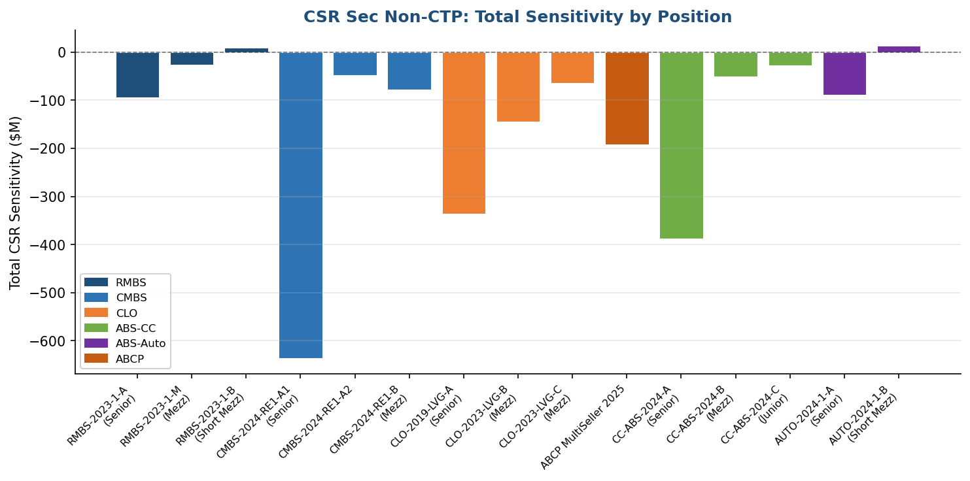
Figure 4: Total CSR Sec sensitivity by position. Long positions show negative values (loss on spread widening). Short positions (RMBS-B, AUTO-B) show positive values.

6.2 GIRR PV01 Sensitivities
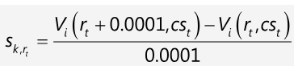
ID | Security | Pool | Total PV01 | Dom. Tenor | Dom. PV01
37 | RMBS-2023-1-A (Senior) | RMBS | $-94.3M | 3.0Y | $-74.2M
38 | RMBS-2023-1-M (Mezz) | RMBS | $-26.7M | 3.0Y | $-20.9M
39 | RMBS-2023-1-B (Short Mezz) | RMBS | $8.9M | 3.0Y | $7.0M
40 | CMBS-2024-RE1-A1 (Senior) | CMBS | $-636.6M | 10.0Y | $-384.1M
41 | CMBS-2024-RE1-A2 | CMBS | $-47.3M | 10.0Y | $-28.4M
42 | CMBS-2024-RE1-B (Mezz) | CMBS | $-78.1M | 10.0Y | $-46.5M
43 | CLO-2019-LVG-A (Senior) | CLO | $-337.8M | 3.0Y | $-141.8M
44 | CLO-2023-LVG-B (Mezz) | CLO | $-145.0M | 3.0Y | $-80.0M
45 | CLO-2023-LVG-C (Mezz) | CLO | $-64.4M | 3.0Y | $-35.6M
46 | ABCP MultiSeller 2025 | ABCP | $-192.4M | 0.5Y | $-134.2M
47 | CC-ABS-2024-A (Senior) | ABS-CreditCard | $-387.2M | 3.0Y | $-266.2M
48 | CC-ABS-2024-B (Mezz) | ABS-CreditCard | $-51.1M | 3.0Y | $-35.1M
49 | CC-ABS-2024-C (Junior) | ABS-CreditCard | $-27.0M | 3.0Y | $-18.5M
50 | AUTO-2024-1-A (Senior) | ABS-Auto | $-89.9M | 3.0Y | $-38.7M
51 | AUTO-2024-1-B (Short Mezz) | ABS-Auto | $13.2M | 3.0Y | $5.6M
Table 7: GIRR PV01 summary. Dominant tenor reflects weighted average life of each tranche. ABCP (ID 46) shows concentration at 0.5Y given its <1-year remaining maturity.

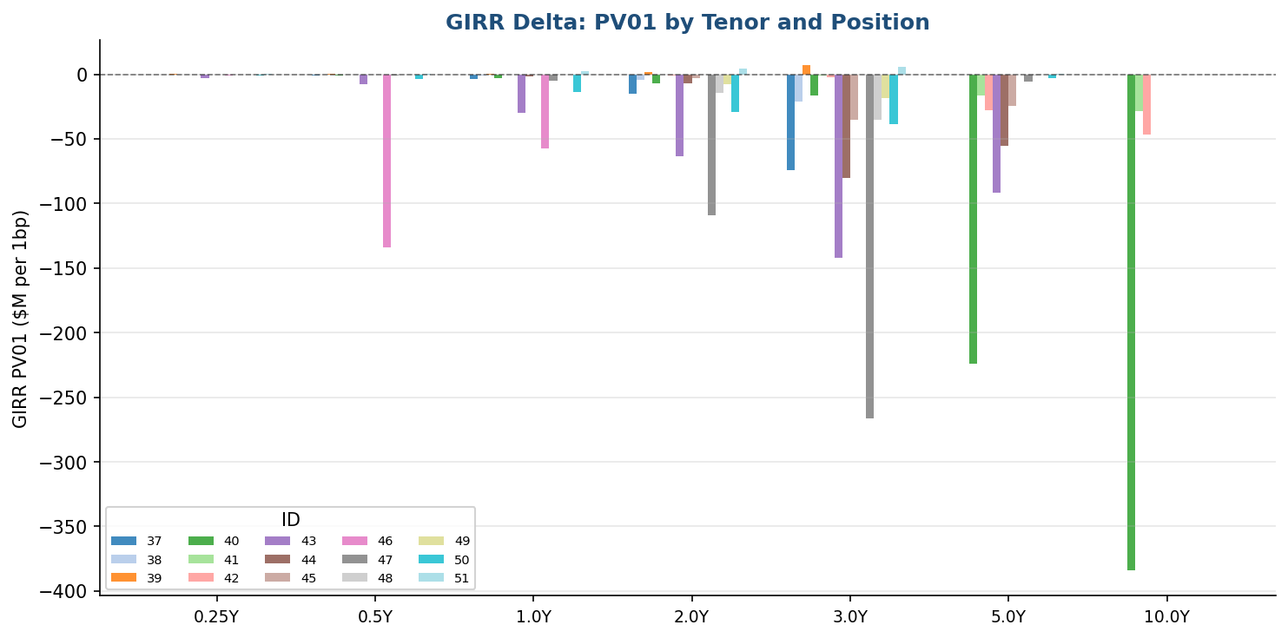
Figure 5: GIRR PV01 by tenor and position. Short-dated assets (RMBS, ABCP) concentrate risk at 0.25Y–3Y; long-dated CMBS/CLO positions extend to 5Y–10Y.

7. Why Sensitivities Matter in FRTB SA Capital
Under the FRTB Standardised Approach (MAR20–MAR23), market risk capital is not computed from historical P&L scenarios as in the Internal Models Approach. Instead, it is derived entirely from instrument-level sensitivities via three sequential steps:
Step 1 — Weighted Sensitivity: Each raw sensitivity s_k is multiplied by its prescribed risk weight RW_k (e.g., 1.5% for GIRR RMBS bucket, 0.5% for AAA CMBS) to give the weighted sensitivity WS_k = RW_k × s_k, expressed in USD capital units.
Step 2 — Bucket Aggregation: Weighted sensitivities within the same MAR22 bucket are aggregated using the intra-bucket correlation matrix ρ_kl. The bucket-level capital K_b is √(Σ_k WS_k² + Σ_k≠l ρ_kl WS_k WS_l). Long and short positions within a bucket partially offset each other, making the correct sign of each sensitivity critical.
Step 3 — Across-Bucket Aggregation: Bucket capitals are aggregated across all MAR22 buckets using the inter-bucket correlation γ_bc under three scenarios: low, medium, and high correlation. The final CSR Sec capital charge is max(low, medium, high). GIRR capital is aggregated separately across the GIRR bucket structure.
The accuracy of each sensitivity therefore has a direct monetary impact on the capital requirement. Errors in either sign or magnitude translate one-for-one into errors in WS_k, affecting both the individual bucket charge and the diversified cross-bucket total. For securitisation positions, which are assigned to specific MAR22.60 buckets (0–16 for Non-CTP), misidentifying the bucket or misstating the sensitivity could place the position in the wrong correlation regime and generate materially incorrect capital.
Having both CSR Sec delta (spread sensitivity) and GIRR delta (interest rate sensitivity) for each tranche ensures that the two orthogonal risk drivers are separately captured, preventing double-counting or under-counting of either dimension when aggregating across a mixed book of bonds, swaps, options, and structured products.

8. Assumptions and Limitations
The following assumptions are made in this implementation. Each has been selected to be conservative where possible and is disclosed here for model risk management and audit purposes.
Assumption | Detail | Impact / Sensitivity
Fixed coupon proxy | All tranches are modelled with a fixed coupon rate equal to the coupon field in the portfolio. In practice many sec tranches pay floating (SOFR + margin). Under SA the sensitivity to the floating rate is captured via GIRR PV01; the fixed cashflow proxy is standard for CS01 computation since it is the spread-driven change in PV that matters. | Immaterial for GIRR; CS01 slightly understated for very short-maturity floating tranches.
CPR — RMBS (8% annual) | Default CPR sourced from long-run prime US RMBS historical prepayment rates. Configurable per position via the assumptions dict in project_tranche_bond(). | CS01 duration shortens as CPR rises; a ±2% CPR change moves total RMBS CS01 by ~±8%.
CLO reinvestment period (5 years) | Industry consensus for CLO 2.0/3.0 (Western Asset/Citi Jan 2021; Invesco Sep 2024; LSEG Yield Book; Deutsche Bank 2026 CLO outlook). Configurable per position. | Longer reinvestment → larger CS01 at short tenors; shorter → larger at long tenors.
ABS-CC controlled amortisation (1 year) | Standard credit card master trust structure. Configurable. | Sensitivity is modest; ±0.5 year change has <5% impact on total CS01.
No scheduled ABS-Auto amortisation overlay | ABS-Auto is modelled as pure linear; no CPR overlay for prepayments. For FRTB SA CS01, prepayment sensitivity is not a prescribed risk factor; the linear profile is sufficient. | May slightly overstate duration at long tenors for high-prepayment vintages.
Tranche spread curves — Level 3 | All tranche curves are manufactured from rating-matched index levels plus thinness premium. No real-time broker quotes are used. Reflects FRTB's acceptance of Level 3 inputs for non-traded instruments under MAR21.12. | Spread levels should be refreshed at each reporting date; stale spreads will understate CS01 for positions that have widened since issue.
SOFR as risk-free rate | Per MAR21.39, USD OIS (SOFR) used throughout. Legacy LIBOR columns in the market data sheet are ignored when SOFR columns are present. | n/a — regulatory requirement.
No curvature or vega for securitisations | MAR21 does not prescribe curvature charge for CSR instruments. Securitisation GIRR does not carry its own vega/curvature (no embedded optionality in the modelled positions). | n/a — regulatory design.
Valuation date fixed at 5 February 2026 | All sensitivities use a single snapshot. A live production system would re-run daily with an updated market data file. | n/a — demonstration portfolio.
Table 8: Model assumptions with rationale and estimated sensitivity to changes.

9. Regulatory References
- MAR20 — FRTB Standardised Approach: overview and scope.
- MAR21.19 — GIRR delta sensitivity definition (PV01 at prescribed tenors).
- MAR21.20 — CSR Non-Sec and Sec delta sensitivity definition (CS01 at prescribed tenors).
- Basel Committee on Banking Supervision, "Minimum capital requirements for market risk", January 2019 (rev. 2024).
- Western Asset / Citi (Jan 2021); Invesco "Understanding CLOs" (Sep 2024) — CLO reinvestment period.
- LSEG Yield Book CLO Primer; Deutsche Bank CLO Outlook 2026 — CLO structural assumptions.

